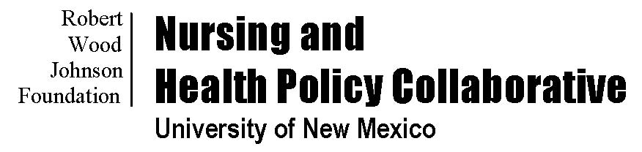
Building Health Policy Competency in Graduate Nursing Programs
SCHEDULE AT A GLANCE
SATURDAY, JANUARY 23, 2016
12:00 pm–1:00 pm
Registration and Buffet Lunch (provided)
Location: The Naples Grande Beach Resort, Orchid Foyer
1:00 pm–1:10 pm
Welcome and Introductions
Susan B. Hassmiller, PhD, RN, FAAN
Nancy Ridenour, PhD, APRN, BC, FAAN
1:10 pm–1:40 pm
Health Professions in Policy Engagement
Robert G. Frank, PhD
Location: The Naples Grande Beach Resort, Orchid Rooms 1, 2
1:40 pm–3:00 pm
Master Teachers Unpack Best Practices
Panel: Harold Pollack, PhD
Nancy Short, DrPH, MBA, RN
Thomas Ricketts, PhD, MPH
Julie A. Sochalski, PhD, RN, FAAN
Moderator: Eileen T. O’Grady, PhD, NP, RN
Location: Naples Grande Beach Resort, Orchid Rooms 1, 2
3:00 pm–3:15 pm
Break
3:15 pm–4:45 pm
Evidence-Based Influence: Research Strategies
Scott Palmer, MA
Location: Naples Grande Beach Resort, Orchid Rooms 1, 2
4:45 pm–5:00 pm
The Task Ahead and Preview of Website

Eileen T. O’Grady, PhD, NP, RN
Location: Naples Grande Beach Resort, Orchid Rooms 1, 2
5:00 pm–7:00 pm
Reception and Poster Session
Location: Naples Grande Beach Resort, Orchid Rooms 2, 3, 4
SUNDAY, JANUARY 24, 2016
8:00 am–8:30 am
Registration and Continental Breakfast (provided)
Location: Naples Grande Beach Resort, Orchid Foyer
8:30 am–8:45 am
Update on Institute of Medicine Future of Nursing Report
Susan B. Hassmiller, PhD, RN, FAAN
Location: Naples Grande Beach Resort, Orchid Rooms 1, 2
8:45 am–10:00 am
Keynote Address: Unleashing Nurses’ Full Potential and Power through Policy Competency
Judith Shamian, PhD, RN, FAAN
Location: Naples Grande Beach Resort, Orchid Rooms 1, 2
10:00 am–10:15 am
Break
10:15 am–12:30 pm
Using Case Studies as a Teaching Strategy
Nancy Short, DrPH, MBA, RN
Harold Pollack, PhD
Location: Naples Grande Beach Resort, Orchid Rooms 1, 2, 3

12:30 pm–1:00 pm
Building the Community: Next Steps
Eileen T. O’Grady, PhD, NP, RN
Susan B. Hassmiller, PhD, RN, FAAN
Alexia Green, PhD, RN, FAAN
Location: Naples Grande Beach Resort, Orchid Rooms 1, 2

